Last updated April 15th 2021

How to register/renew as an OSA student member:

- (Only for new people, if you are renewing go directly to step 2)
Go to https://www.osapublishing.org and click on “Login or Create Account.” Select, of course “create account.”
  - Use preferably your Fresnel email account.
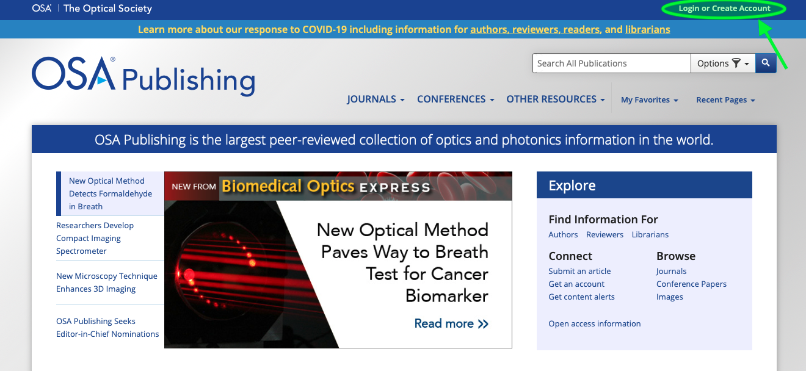

- Once you created your account, login and click on “My Account.” Then click on “Personal Profile” inside Mange my profile.
  - You will be redirected to a new page where you will have to login again with your same credentials.
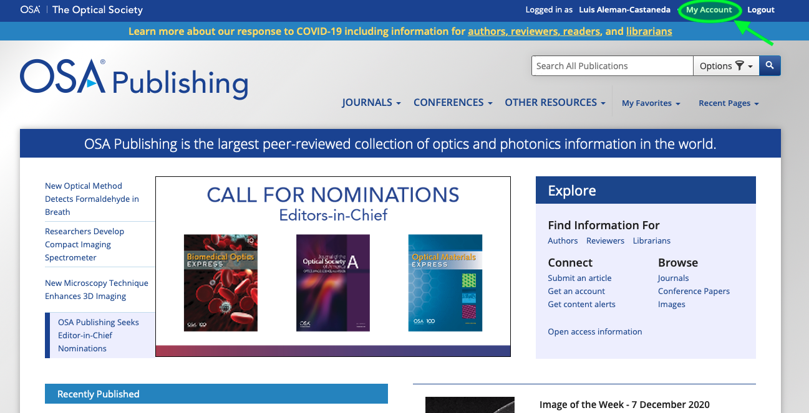

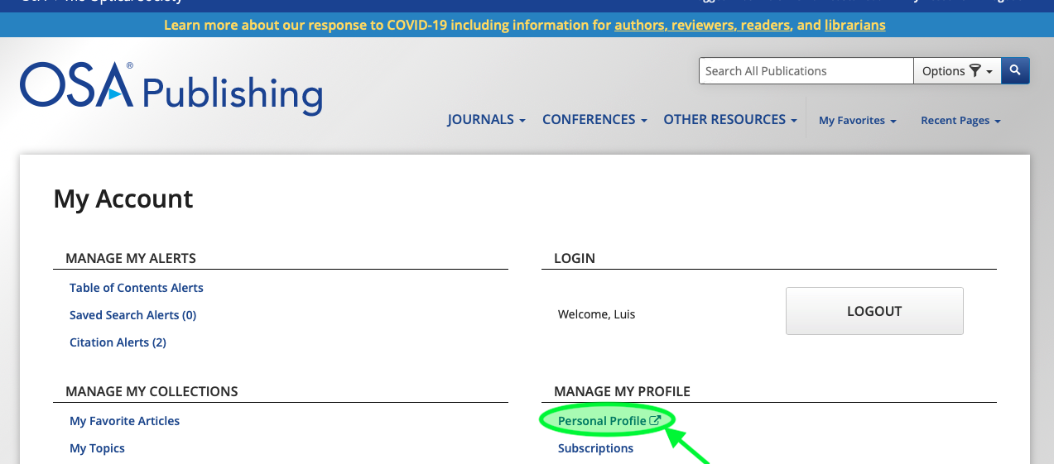

- Once you are in your account, go to the tab “membership.” There follow the steps to become a member. At the end of the registration you will be asked to pay, there are two main options for your membership:
  - Pay per year, which results in $20.
  - Pay per three years, which results in $50 (so cheaper in the long run).

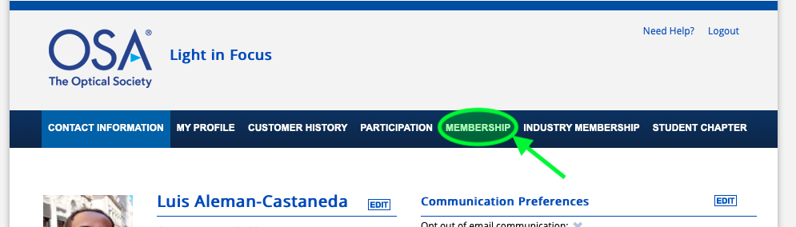

- Then go to Student Chapter, select as country France and “Marseille ElectroMagnetism and Optics (MEMO) Student Association” should appear as an option. Select it.

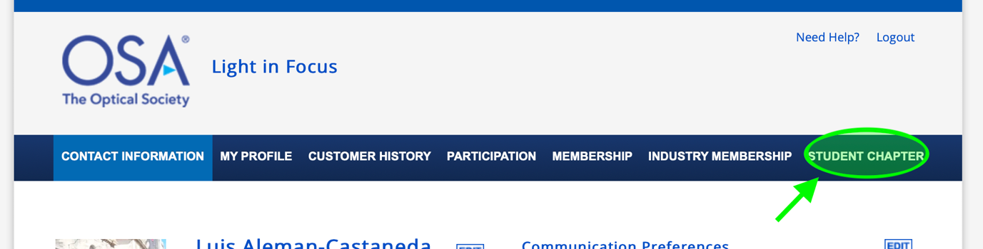

- You are done! Just communicate your information to the administration board of MEMO Chapter or email us your information at memo.studentchapter@gmail.com. PLEASE send us when your membership is expiring, so we can have better control on our membership numbers.

