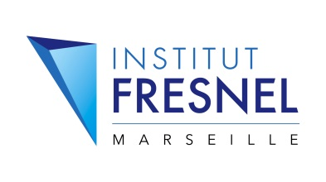
Research Opportunity at Institut Fresnel
Internship in Biomedical Optics
Non invasive glucose sensing

Advisors : Dr. Anabela Da Silva
Tel +33 4 91 28 84 82
E-mail anabela.dasilva@fresnel.fr
Group DiMABio, Institut Fresnel
Address Institut Fresnel, Av Escadrille Normandie-Niémen, 13397 Marseille Cedex 20

Applications are invited for an internship in Biomedical Optics at the Institut Fresnel, University of Aix-Marseille, France. Persons with a combination of experimental and theoretical skills with good computational background are particularly encouraged to apply.

Background: As an alternative to the conventional biomedical imaging modalities such as X-Ray CT, MRI, PET, SPECT, etc., optical methods, such as diffuse optical tomography (DOT), are attracting significant attention in the contemporary biomedical research due to their non-invasive nature and sensitivity to the physiologically-important contrast that is not easily accessible with other approaches. Optical parameters of tissues are intrinsic biomarkers that provide information on metabolism and physiology of tissues and organs. Diffuse optical techniques can be used to image vascularization, hemodynamic parameters, and oxygen saturation, in the so-called “therapeutic window” (600-900 nm). Typical applications involve breast and brain imaging. The main drawback of DOT is that biological tissues are highly scattering in the spectral window of interest. This requires utilization of complex mathematical models of light propagation in tissues. In the present collaborative project, we are interested in optical monitoring of glucose in order to develop a method for non invasive monitoring of diabetic patients. An innovative wearable detector has been developed by our partner and is to be tested.

Research program:
- To perform demonstrative tests with the wearable detector in order to evaluate in vivo feasibility.
- To perform experiments in vitro and in tissues ex vivo.
- To solve the inverse problem with developed reconstruction softwares based on the modeling of polarized light propagation through biological tissues (Monte Carlo simulations) in order to retrieve quantitative information on the physiology of the tissues (glucose concentration).

